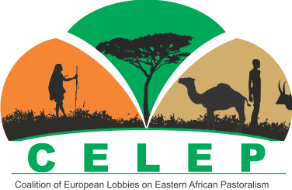

**Report on 9th CELEP Annual General Meeting**

**Brussels, 28–30 November 2018**

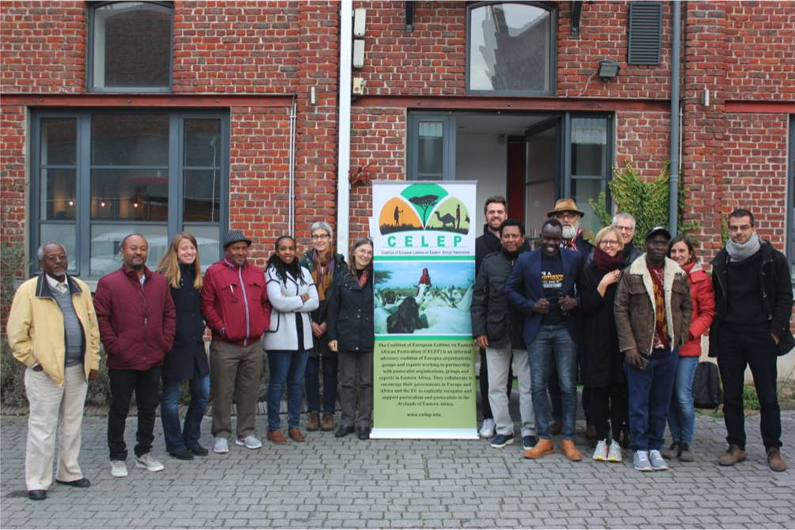

# **Acronyms**

|  |  |
| --- | --- |
| **Acronym** | **Name** |
| **AGM** | Annual General Meeting |
| **DFF** | Decade of Family Farming |
| **DG DEVCO** | Directorate General for International Cooperation and Development |
| **EC** | European Commission |
| **EU** | European Union |
| **KDF** | Karamoja Development Forum |
| **ILC RI** | International Land Coalition Rangelands Initiative |
| **ILRI** | International Livestock Research Institute |
| **IUCN** | International Union for the Conservation of Nature |
| **IYRP** | International Year of Rangelands & Pastoralists |
| **PARD** | Partners to Rural Development |
| **PAPDA** | Partnership for Pastoralists Development Association |
| **RECONCILE** | Resource Conflict Institute |
| **SNV** | Stichting Nederlandse Vrijwilligers |
| **S&D** | Socialists & Democrats group European Parliament |
| **UCRT** | Ujamaa Community Resource Team |
| **UNEA** | United Nations Environment Assembly |
| **UNGA** | United Nations General Assembly |
| **VSFB** | Vétérinaires Sans Frontières Belgium |
| **WTO** | World Trade Organization |

# **Agenda**

## **DAY 1: WEDNESDAY 28 NOVEMBER**

|  |  |
| --- | --- |
| **Time** | **Subject** |
| 13:00 – 14:00 | **Lunch at the Funkey Hotel** |
| 14:00 – 16:00 | **Opening session: Presentations by members of past activities on pastoralism**  Welcoming words by host organisation VSF-Belgium  Presentation of participants and their work on pastoralism in Eastern Africa: each participant from a European member organisation or an Eastern African partner organisation gives a short presentation (ca. 7–10 minutes) on their activities related to pastoralism. Participants wanting to use PowerPoint should **send the PPT file to the European Focal Point by 21 November.**  Questions and answers |
| **16:00 – 16:30** | **Coffee break** |
| 16:00 – 17:30 | **CELEP activities in 2018**  Presenting past activities within the CELEP network by the CELEP European and Eastern African Focal Points, based on the annual report |
| 19:00 | Networking dinner at Bar du Gaspi 309 chaussée de Haecht 1030 Bruxelles (<http://www.bardugaspi.com/>). The restaurant is within walking distance of the hotel (about 20 minutes). |

## **DAY 2: THURSDAY 29 NOVEMBER**

|  |  |
| --- | --- |
| **Time** | **Subject** |
| 09:00 – 11:00 | Presentation/discussion on EU development policies in 2019: focus on post-Cotonou agreement negotiations – Mark Maes (11-11-11, Belgian platform of NGOs) + Q&A. The aim of this session is to inspire the work of the working groups afterwards. |
| 11:00 – 11:30 | Coffee break + Departure for Infopoint at the EC (DG DEVCO) |
| 12:30 – 14:00 | Presentations at EC InfoPoint on *Linking pastoralist research and policies*:   * *Making regional and national policies and processes to secure rangelands and pastoralism*, Peter Ken Otieno, Technical Coordinator of the Rangelands Initiative Programme Africa Component at RECONCILE and CELEP regional focal point, Kenya * *Linking research and policy processes related to pastoral development: the case of the “Focus on Ethiopia” project*, Francesco Staro, Anthropologist, University of Paris 8 - Saint Denis, France * *Advancement in inclusive pastoral policy process: prospect and challenge in the reforms in Ethiopia,* Tezera Getahun, Pastoralist Forum Ethiopia |
| 14:30 – 15:00 | Walk back to the Funkey Hotel + lunch break at the hotel |
| 15:00 – 15 :30 | Participating members and partners present initial ideas on activities that they would like to develop through/with CELEP in 2019. |
| 15 :30 - 17 :30 | Working groups: identifying new activities for CELEP for 2019 related to   * Communication/Knowledge management * Advocacy/lobbying |

## **DAY 3: FRIDAY 30 NOVEMBER**

|  |  |
| --- | --- |
| Time | Subject |
| 09:00 – 10:30 | Presentation of action plan by rapporteurs of each working group + Q&A |
| **10:30 –** **11:00** | **Coffee break** |
| 11:00 – 13:00 | **Discussion on organisational set-up CELEP** to see:   * If it is still coherent with our objectives and the changing context regarding EU decision making on development * Which ideas/options we can develop to increase funding for CELEP   **Parking lot discussion and AOB** |
| **13:00 – 14:00** | **End of the meeting + goodbye** |

# **Summary of the sessions**

## **Day 1**

#### **Opening session + Presentations of members**

**Koen Van Troos** who works for **Vétérinaires Sans Frontières Belgium (VSFB)**, the CELEP focal point in Europe since 2013, made the opening remarks to start the CELEP Annual General Meeting (AGM). He started with a presentation reiterating the goals and mission of CELEP regarding lobbying national governments, European Union (EU) bodies and more to recognise and support pastoralism in Eastern Africa. The presentation also discussed past results and the impact the organisation has had on EU development policies. You can find his presentation [**here**](https://drive.google.com/file/d/1wjxQs6Zkjck6c5A-xFcpadFurQ9sRoHH/view?usp=sharing).

Following this introductory presentation, several participants briefly presented their organisation and past activities related to pastoralism:

* **Ken Otieno – RECONCILE, regional focal point for CELEP:** RECONCILE is an organisation working on policy research, capacity building and advocacy focusing on land, environment, forestry, agriculture, fisheries and pastoralism. The organisation works closely with a wide variety of organisations throughout the African region. The focus of Ken’s presentation was on the work RECONCILE is doing as coordinator of the Africa part of the International Land Coalition Rangelands Initiative. He looked at issues such as conflicts over shared resources and climate-change effects such as drought and flooding. You can find his presentation [**here**](https://drive.google.com/file/d/109mC1Rolv8fZGsObvCoQOVBfC-gYXmCZ/view?usp=sharing)**.**
* **Uli Schwarz – up4change e.V**: EEEM is a small NGO working in Northern Kenya on Ethno E-EMpowerment bringing culture, anthropology, digital technology and education together to empower local communities, with a focus on girls and women. It offers pastoralists an alternative to traditional education, which often does not suit their way of life. The NGO also helps the digital preservation of traditional knowledge, to increase literacy and numeracy, knowledge transfer and awareness-raising. You can find his presentation [**here**](https://drive.google.com/file/d/1JA0CBTdtiMd3LwPu_SgbQjbv1zTmFDOE/view?usp=sharing)**.**
* **Anamo Eyasu Yonas – Misereor**: Yonas presented the Misereor-funded project of the Jinka Branch of the Ethiopian Catholic Church. It operates in three districts of Ethiopia and focuses on education, livestock production, women’s economic empowerment, potable water provision and human health. It aims at helping marginalised pastoralist communities and assists more than 35,000 people. You can find his presentation [here.](https://drive.google.com/file/d/1QpWNeJ90MiYKTvqsf8uwP_0EnClKwnTJ/view?usp=sharing)
* **Caroline te Pas – SNV Netherlands**: As time was running out, Caroline quickly presented the work of SNV, which works in over 30 countries focusing on agriculture, energy and water. SNV also has a focus on pastoralism with 15 projects in seven countries in Africa. Their work involves, for example, strengthening advocacy capacities of local organisations (such as through the Voice for Change programme), creating co-managed livestock markets and setting up a mobile information system for pastoralists. You can find her presentation [**here**](https://drive.google.com/file/d/1wcr7EXrCq-D2gOoSLaN_OEOTT-a4bEW8/view?usp=sharing)**.**
* **Abdulqadir Mah Noor – Partnership for Pastoralists Development Association (PAPDA)**: Adbulqadir presented the Guwash project for PAPDA, a partner of Misereor. The project focuses on improving water usage, quality and quantity for pastoralists in the region, by constructing and drilling boreholes and ponds. The goal is to create community ownership and management to reduce conflicts over resources and increase mobility. Adbulqadir also talked about the challenges that NGOs face in Ethiopia, such as daily monitoring.
* **Tebanyang Emmanuel – Karamoja Development Forum (KDF)**: KDF focuses on land, pastoralism and governance in the region of Karamoja, Uganda. Teba quickly presented the objectives and the challenges that pastoralists face in Uganda. The biggest threat is the determination of the government to abolish pastoralism through forced settlement and/or land privatisation. KdF aims at advocating for the pastoralist way of life but also improving pastoralists’ communication through phones and access to local markets. You can find his presentation [**here**](https://drive.google.com/file/d/1VXaVBa9tyQjCNiSxIUQbUOgkznfuLXxF/view?usp=sharing)**.**
* **Paine Mako – Ujamaa Community Resource Team (UCRT)**: Another country represented at the AGM was Tanzania with the UCRT, working in eight districts. The core goals of the NGO are securing community land rights, developing institutions, strengthening resource management, increasing opportunities and improving social empowerment and equality. Paine presented rapidly two projects of the UCRT: Maisha Bora and Land Enhancing Governance for Economic Development. Both projects focus on securing grazing lands for pastoralists, who are in danger from land grabbing, long-term conflicts and new wildlife corridor policies. You can find her presentation [here](https://drive.google.com/file/d/1a08L5jIsMVBCBznBdbcg_UqPXVvIZ8Ij/view?usp=sharing).
* **Alemayehu Kasaye Tegene – Partners to Rural Development (PARD)**: Tegene works for the Pastoral Development unit of PARD, a partner of Misereor. The presentation focused on the projects in the Afar Region of Ethiopia, dealing with land-use problems, conflicts, deforestation, prosopis invasion and poor resource management. You can find his presentation [here](https://drive.google.com/file/d/1F-NWs3hl9aguBJybvah2RUyWqIV5WLn4/view?usp=sharing).
* **Harma Rademaker – Cordaid**: The last presentation was made by Harma on behalf of Cordaid, which coordinates several programmes on resilience, resource management and climate change and also works with other international organisations. Cordaid has a specific programme called Partners for Resilience, which focuses on capacity building, advocacy and helping local NGOs negotiate with government officials with a view to resilience and disaster risk reduction

***Presenting the activities of CELEP in 2018***

After the presentations by members and partners, Koen presented a summary of the CELEP activities during the year 2018, based on the CELEP engagement strategy, focusing on lobbying, communication and knowledge management and the actions that were agreed during the previous AGM. The communication activities in 2018 revolved mainly around the revamping of the CELEP website with a news section and an active Twitter account. Present members and partners were encouraged to advertise the website, to use the knowledge repository as much as possible and to tag CELEP (@CELEP_FP) through Twitter.

Koen also presented the data regarding website visits, downloads of documents, etc. The recent integration of a special focus on Ethiopia was also discussed. The second summary revolved around knowledge management, highlighting specifically the dairy learning tour organised in Kenya and the different papers and policy briefs that were published throughout the year, such as on dairying, land and SDGs. Lastly, he gave an overview of the various advocacy activities at the European level as well as activities regarding capacity development of CELEP members and partners on advocacy. Some of these activities included CELEP's involvement in the Tropentag, the European Development Days, the Expert hearing on the Common Agriculture Policy, the Africa S&D week and the Participatory Rangeland Management (PRM) project. He closed with some words about the future of CELEP and the activities envisioned for 2019, inviting the members and partners present and not present to develop ideas for CELEP's future.

You can find Koen's presentation [here](https://drive.google.com/file/d/1WqcarlV6pmgbTfWDQU3Ffa7pbI2oPe1C/view?usp=sharing).

## **Day 2**

#### **Presentation/discussion on EU development policies in 2019: focus on post-Cotonou agreement negotiations**

The second day of the AGM started with a presentation by Marc Maes, who works with 11 11 11, a Belgian platforms of NGOs. Marc’s presentation focused on the follow-up to the Cotonou agreement and what is at stake when the agreement will end in 2020. After a brief summary about the history of the Cotonou agreement, Marc talked about the changes in the political environment in Europe. Since 2000 and the start of the last Cotonou agreement, the European Union has changed a lot. Marc talked in detail about the EU enlargement, the failed WTO Doha agreement, the rise of China, the global crisis, the GSP (Generalised System of Preferences) reform but also the refugee crisis, terrorism and the wide rise of populism and nationalism in Europe, which all have affected EU policies greatly. The EU changed its global strategy and, more importantly, its development strategy with an increased instrumentalisation of official development aid for security but also commercial and migration objectives. The EU now wants return on its investments (following in the footsteps of China). At the same time, we see fewer resources going to development goals to fight poverty or hunger, for instance. Marc then talked about the proposed follow-up change for the new agreement, which seems to be more based on EU interests and values. The new negotiation position of the Commission is still based on the three regional ACP pillars of the Cotonou agreement (Africa, Caribbean and the Pacific Islands). Marc concluded his presentation with a special focus on CELEP's interests, showing the language used in the EU text that is now being negotiated as mandate to follow up on the Cotonou agreement. There is mention of animal health, water conservation, sustainable management of natural resources, responsible tenure of land but not of pastoralism as such. However, according to Marc, these are potential entry-points for CELEP to work on to push for pastoralism. Other entry points include the mention of land degradation, early warning systems and tackling of drought, for example. You can find Marc’s presentation [here](https://drive.google.com/file/d/1id-GOUnW6gyojpIb6OsvihfmZMUZ3U3U/view?usp=sharing).

The presentation was well received by the participants and was followed by a debate revolving around the possible entry-point of CELEP and the future of small-scale farming. Member of Parliament Maria Arena was also cited as a potential entry-point at the European Parliament. Follow-up actions will most certainly be developed by the core-group and the focal points.

#### **Infopoint at the European Commission**

After a short break, the whole group went to the External Co-operation Infopoint of the European Commission (EC), where CELEP through its European focal point VSFB organised an Infopoint lunch-conference on **Linking research to policies and practices: experiences in pastoralism in Eastern Africa**. The Infopoint session involved three presentations made by Peter Ken Otieno (RECONCILE), Francesco Staro (University of Paris 8) and Tezera Getahun (Pastoralist Forum Ethiopia). This session was recorded and can be watched through this [link](https://ec.europa.eu/europeaid/news-and-events/linking-research-policies-and-practices_en).

Williem Olthof, deputy head of the unit at DEVCO Unit C.1, made the introduction on behalf of the Commission. In his introduction, he recognised the growing influence of pastoralism as an important livelihood and referred to his own experiences regarding pastoralism in Ethiopia.

Following this brief introduction, Ken made the first presentation**.** He focused on the issue of rangelands and pastoralism. He affirmed the complementarity between rangelands and pastoralism and the need for a better coordination of policies affecting both issues. Ken put forward the resilience capacity and adaptive capacities of pastoralist communities whilst stressing the need for greater help to protect their environment and their mobility. He then proposed different policy measures regarding land and water rights, mobility, women’s rights, climate adaptation and many more. Pastoralists are essential guardians of the rangelands and therefore must be seen as a solution rather than a problem. You can find Ken's presentation [here](https://drive.google.com/file/d/1JBSrz3X5GJlf7F4M0jh506FChx8sxOF0/view?usp=sharing).

Francesco Staro, researcher and anthropologist at the University Paris 8, made the second presentation. It was on the project “Focus on Ethiopia”, which aims to fill the gap between scientific research and pastoral development policy and practices. He focused on the practical example of water development issues in particular in the Southern Region of Ethiopia and what he called “the de-socialisation of water resources”. He questioned dominant stereotypes regarding pastoralism and stressed the need for more scientific research in order to have better targeted development policies. You can find his presentation [here](https://drive.google.com/file/d/1EQcLz8qfJhTqjLPdFg5quaPg_yHPU31r/view?usp=sharing).

The last presentation was made by **Tezera Getahun**,Executive Director of Pastoralist Forum Ethiopia (PFE). His aim was to inform on the broader context and significance of pastoralism in Ethiopia, its sustainable development and the current policy environment affecting pastoralism in the country. Tezera reminded the public of the economic importance of pastoralism and the contradictory marginalisation that it faces. He called upon the EC to help create a more resilient and sustainable pastoralism and recognise its value. You can find his presentation [here](https://drive.google.com/file/d/1Ym0zTmrBUsbyVt2QV7xczCQfJzWY418X/view?usp=sharing).

Following these presentations, the public was invited to ask questions to the speakers. Several officers working for the DEVCO Unit C.1 took part in the discussion. One of the discussion points was the question of the regional rangelands policy framework. Ken argued that there is nowadays no regional framework and there is no protection for pastoralism at that level. However, some countries possess national policy frameworks on rangelands and land such as Kenya or Uganda but those remain at the national level. Because of the transboundary nature of rangelands and pastoralism, however, there is a need for better coordination of rangeland policy at regional level. Another discussion point was the question of conflicts in pastoral areas on account of external investment. Tezera talked about the example of the large-scale investment in agriculture that has an impact on pastoralist land because of a lack of political protection. The government prefers crop agriculture over pastoralism despite the proven economic value of pastoralism in the drylands. These policies exacerbate conflicts between pastoralist and farmers over land. The three speakers put forward the lack of development policies formulated for and with pastoralists. Current policies seem to focus more on the forced sedentarisation of these communities or chasing them from their land so that it can be used for crop agriculture, petrol exploration or mineral exploitation. They called upon the EC to assist their governments in coming up with a long-term strategy regarding rangelands, climate adaptability and more, so that the pastoralist system can be developed and the livelihoods of pastoralists can be supported

The lunch-conference ended with a discussion on the sensitive issue of NGO legislation in Ethiopia and the difficulty for NGOs to work in this environment. Tezera stated that it is getting easier but governmental constraints are still present and cause difficulties. He therefore called for more support from the EU to help NGOs develop their activities in the changing policy environment. The conclusions of the different speakers focused on the need for a clear strategy for pastoralist development and the creation of a roadmap to increase pastoral sustainability, resilience and better conflict management.

#### **Activities for 2019: working groups**

After the Infopoint conference, the group headed back to the Funkey Hotel to discuss future activities of CELEP and to establish an action plan for 2019. Several propositions and inputs were sent in beforehand, notably on the question of digitalisation and education, the International Year of Rangelands and Pastoralists (IYRP) and the UNEA conference in March in Nairobi, Ethiopia Pastoralist Day, a global campaign on mobility, etc. You can find all of the information that was sent in beforehand [here](https://drive.google.com/drive/folders/1dxXocFWpQx07CiOSrEgc3udfRjMSgy_k). There were also suggestions to work on a regional conference in Karamoja, a baseline study on pastoralist policies and laws, etc. The members and partners who had sent in this information were asked to pitch the activity they propose. Following this presentation round, the following working groups were set up to develop each activity in depth:

1. Education and digitalisation
2. Global joint campaign on pastoral mobility
3. Working group on Ethiopia (Ethiopia Pastoralist Day, Focus on Ethiopia, Conference on pastoralism in Ethiopia supported by Misereor)
4. Fundamentals of CELEP advocacy.

## **Day 3**

#### **Presentations of the working groups**

The results of the working groups were put together into a comprehensive action plan related to the CELEP engagement strategy. You can find the action plan [here.](https://drive.google.com/open?id=1Y1PveyfC8t2FMJ0Vs9PIHc-OPUS5fr0Yydf-Nz0iYeI)

* The first working group focused on **education and digitalisation**. Their work focused on the writing of a policy brief on education. The goal is to gather best practices and strategies on education for pastoralists and to give relevant policy recommendations. EEEM will also create a short video to support the global campaign on mobility.
* The second group focused on a **global campaign on pastoral mobility.** The working group proposed to take part in different events and conferences throughout next year and to link up with relevant other platforms such as the International Land Coalition Rangelands Initiative (ILC-RI), the IUCN, the IYRP and the United Nations Decade of Family Farming (DFF).
* The third group **focusing on Ethiopia** had a large number of participants working in that country. The group would like to focus on gathering best practises regarding the clearing of prosopis. They will propose how CELEP can support certain activities related to Ethiopian Pastoralist Day and they will work on a conference to be organised by Misereor before the end of the year in Ethiopia. In the group, Francesco Staro will act as the link between researchers and NGO groups to identify thematic actions and to share best practices through the Focus on Ethiopia section on the CELEP website.
* The fourth group discussed **the broader subject of advocacy for pastoralism in Eastern Africa.** One of the main actions they proposed was to review the policy baseline on pastoralism at the Eastern African and the EU level in order to enable more targeted advocacy. Another activity proposed is to organise an event for the 10-year anniversary of CELEP. An event will be organised at the European Parliament in October/November 2019, at the same time of the next AGM. For this event, a photo exhibit will be prepared together with Tearfund. In addition to celebrating 10 years of CELEP, the group suggested evaluating the work done by CELEP in the past decade, its results and the impact so far. Other possible activities revolve around the post-Cotonou agreement in partnership with Cordaid.

#### **SWOT analysis**

The last activity of this year’s AGM was a SWOT analysis to identify the Strengths, Weaknesses, Opportunities and Threats of the coalition. Each participant was asked to propose one or several elements for the four categories of the SWOT analysis.

**Strengths**

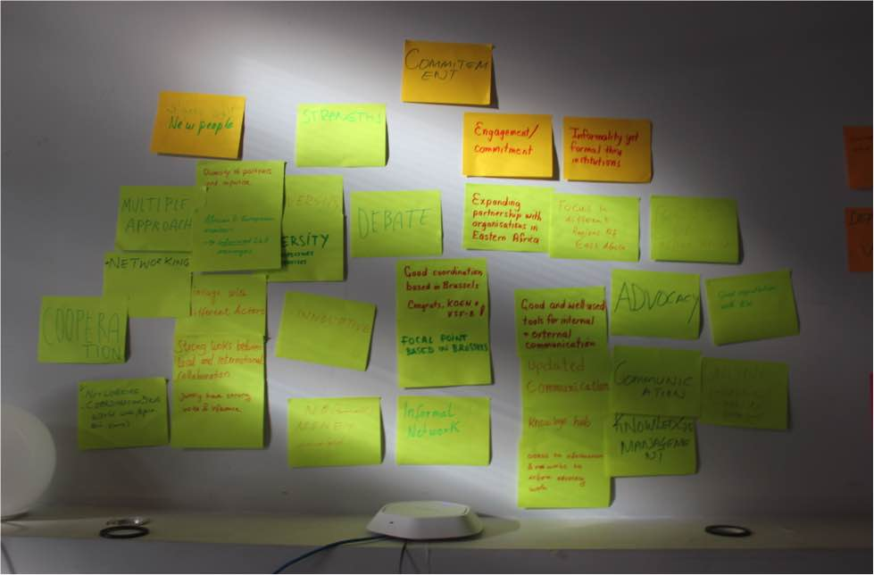

What came out of the discussion on strengths was, first and foremost, the commitment of the members, the knowledge repository on the website, the diversity of the members and partners, and the networking through CELEP. The core-group will consider these results and see how actions can be developed based on these assets.

**Weaknesses**

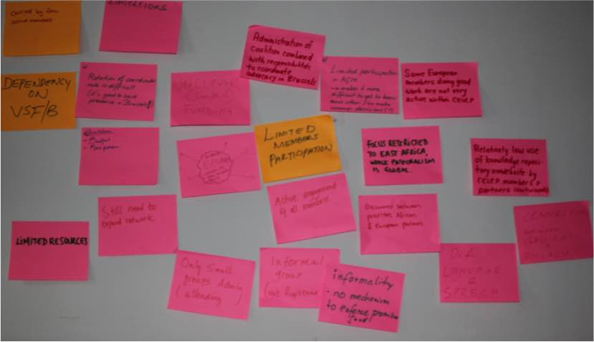

Some of the weaknesses included limited member participation, limited resources, dependency on key members and the restriction to Eastern Africa.

**Opportunities**

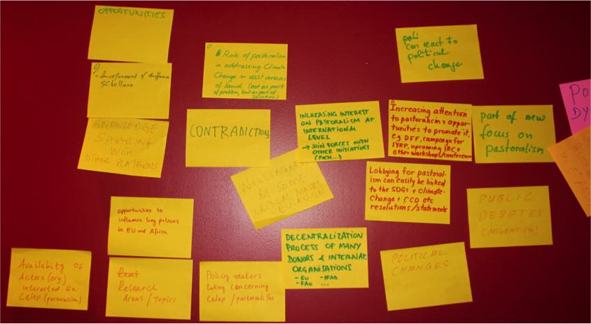

As for the opportunities, there is a growing opportunity to talk about pastoralism in the current political climate and especially in relation to climate change and sustainability. Pastoralism is also seen in a more positive light in recent years, and it is easier to engage in a positive debate on this subject.

**Threats**

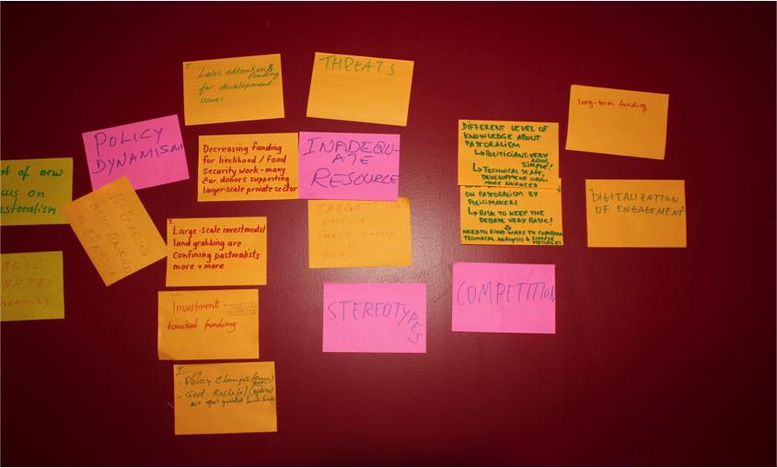

Lastly, the threats for the organisation were mainly considered to be in the reduction of funding for development issues and the increased focus on security. The lack of knowledge about pastoralism by politicians in Eastern Africa was seen as a risk, as this leads to favouring other investments.

#### **Any other business**

After the SWOT analysis, the trust in the focal point and the core-group was re-affirmed to continue throughout 2019. However, **the core-group will still be open to other potential members and partners interested in joining**. One of the first tasks for the core-group will be to follow up on the AGM including following up on the Infopoint with DG DEVCO, defining a date for the next AGM (which will very likely take place in Brussels again) and following up on the action plan that came out of this AGM.

# Annex 1: List of participants

|  |  |  |  |  |
| --- | --- | --- | --- | --- |
|  | **Surname** | **First Name** | **Organisation** | **Email** |
| **1** | Alemayehu | Kasaye Tegene | PARD (partner of Misereor) | pardethiopia2013@gmail.com |
| **2** | Anamo | Eyasu Yonas | Misereor partner | joshuayod@gmail.com |
| **3** | Biedermann | Jérémy | VSFB | dear.trainee@vsf-belgium.org |
| **4** | Gebre-Selassie | Atsbaha | Misereor | atgselassie@yahoo.com |
| **5** | Heikkila | Sini Maria | Tearfund | sini.heikkila@tearfund.org |
| **6** | Mako | Paine | UCRT | manager@ujamaa-crt.org |
| **7** | Noor | Abdulqadir Mah | PAPDA (partner of Misereor) | cabdimaax@yahoo.com |
| **8** | Otieno | Peter Ken | RECONCILE - CELEP regional focal point | kenotieno@reconcile-ea.org |
| **9** | Rademaker | Harma | Catholic Organization for Relief and Development Aid (Cordaid) | harma.rademaker@cordaid.org |
| **10** | Schwarz | Uli | up4change e.V. with eeem.org | schwarz@eeem.org |
| **11** | Staro | Francesco | University of Paris 8 – Saint Denis | francesco.staro@gmail.com |
| **12** | te Pas | Caroline | SNV Netherlands Development Organisation | ctepas@snv.org |
| **13** | Tebanyang | Emmanuel | Karamoja Development Forum | teba.emma09@gmail.com |
| **14** | Tiruneh | Tezera Getahun | Pastoralist Forum Ethiopia | tezerag@yahoo.co.uk |
| **15** | Van Troos | Koen | VSFB/CELEP | k.vantroos@vsf-belgium.org |
| **16-17** | Waters-Bayer + Bayer | Ann + Wolfgang | Agrecol Association | waters-bayer@web.de / wb_bayer@web.de |